Risk Management Policy

Purpose
This policy is designed to outline a framework for the control, minimization, or elimination of the risks associated with the Club’s activities.
Policy Statements
Risks are inherent in every element of community sport and Football specifically, and our Club recognizes the role of appropriate risk management as essential to providing our activities to club members in a safe and controlled manner.

Our Risk Management strategy is a systematic process that enables the identification, assessment, communication, and minimization/removal of risks that can negatively influence the organization, our environment, and our members.

The effective implementation of the Risk Management Policy requires a consistent and systematic approach to risk management at all levels club operations.
Procedures
Our Club will adhere to the following procedures to manage inherent risks of our activities:

- Encourage the ongoing identification/reporting of potential risks to all members of the Committee and wider club community.
- Identify, report, and evaluate the liability associated with all risks.
- Establish the extent of all identified risks.
- Record all risks through a risk management plan/register as shown below.
- Develop and implement ongoing strategies to mitigate, minimize or eliminate risks.
- Support and promote a culture of risk management practices.
- Reduce the cost of insurance premiums and instances of any potential claims.
- Protect the reputation, brand, and image of the Club.

The risk management systems will be reviewed regularly to ensure the actions remain appropriate and effective.

Risk Management Action Plan
The following plan (listed at Appendix 1) has been developed in accordance with the above Risk Management Policy to maintain a record of identified risks, the responses, and necessary actions taken as a result.
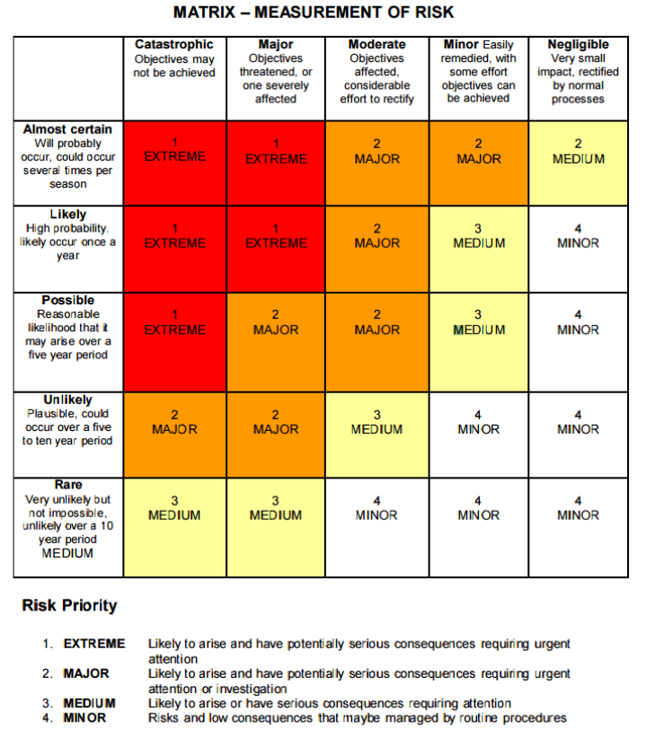

Disclaimer
DISCLAIMER: While all care has been taken in the preparation of this material and the entire FV Resource Library, no responsibility is accepted by the author(s) or Football Victoria, its staff, volunteers or partners, for any errors, omissions or inaccuracies. The material provided in this resource has been prepared to provide general information and guidance only. It is not intended to be relied upon or be a substitute for legal or other professional advice. No responsibility will be accepted by the author(s) or Football Victoria or its staff, volunteers or partners for any known or unknown consequences that may result from reliance on any information provided in this publication.

Appendix 1. Risk Management Plan
Risk | Likelihood | Severity | Risk Rating | Treatment | Responsible Persons
Collapse of Goals | Rare | Moderate | 4 | Goals on pitch should be checked by referee before each match.  In the event of a damaged Goal post:  Match not to proceed, report to Club Coach Coordinator or club official to assess the situation.  If possible, game to be relocated to another ground.  Formal report is to be written up and referred to the Club Committee.  Club Committee to address the incident with the <Insert league acronym> for rectification. | Game Referee  Ground Marshall  <Insert club acronym> Committee  <Insert league acronym>
Damage to balls (peeling leather, etc) | Likely | Negligible | 4 | Damaged Balls not to be used for games or training.  Damaged Balls should be reported & returned to the Team Manager for replacement.  Damaged Balls to be disposed (Eg. leather peels off, change in shape, etc). | Team Manager  Team Coach  Committee

Risk | Likelihood | Severity | Risk Rating | Treatment | Responsible Persons
General pitch conditions:  Presence of Holes  Uneven Ground  Presence of Foreign Objects | Likely | Minor | 3 | Referees to check pitch conditions before games.  Minor Damage:  Report to Club Coach Coordinator or club official to rectify for game to continue.  Major Damage:  Match not to proceed - report to Club Coach Coordinator or club official to assess the situation.  If possible, game to be relocated to another ground.  Formal report is to be written up and referred to the <Insert club acronym> Committee.  <Insert club acronym> Committee to address the incident with the <Insert league acronym> for rectification. | Game Referee  Ground Marshall  <Insert club acronym> Committee  <Insert league acronym>
Equipment Conditions:  Footwear/Shin Guards  Sharp Studs | Rare | Negligible | 4 | Referees to check players footwear for sharp studs before matches.  If a player is not wearing the correct soccer boots and shin guards, they will not be permitted to play or train.  Team Coach to remind players/parents of the correct procedure. | Game Referee  Team Coach  Player

Risk | Likelihood | Severity | Risk Rating | Treatment | Responsible Persons
Weather | Likely | Negligible | 4 | Any training sessions, games, trials, or activities sanctioned by FV/<Insert league acronym> shall be cancelled if the official forecast temperature is 33 degrees Celsius or greater.  Any training sessions, games, trials, or activities sanctioned by FV/<Insert league acronym> will not continue or be played whilst there is hail falling onto the ground or there are thunder and lightning storms in the immediate vicinity.  If the forecast for the game day is extreme wet weather the Club Coach Coordinator or Club Official will contact the relevant authority the day before. With approval the game can be postponed, rescheduled, cancelled, and/or will not be replayed.  The visiting coach must be contacted immediately and advise of the cancellation. | Club Coach Coordinator  Game Referee  <Insert league acronym>  Team Coach  <Insert club acronym> Committee
Exhaustion/Dehydration | Likely | Negligible | 4 | Players are required to supply their own drink; or buy them on the day.  Team Coach to ensure that adequate hydration breaks at training (frequency will depend on the conditions). | Player Team Coach
Physical injuries from regular play | Likely | Minor | 3 | Players should warm up and cool down properly before and after match.  Each Team Coach has access to an adequately stocked first aid kit.  Players with injuries or medical complaints should let these be known to their Team Coach.  Team Coach will not allow any player to play or train with a serious injury | Team Coach  Team Manager  <Insert club acronym> Committee
Risk | Likelihood | Severity | Risk Rating | Treatment | Responsible Persons
Misconduct under any applicable Code of Conduct | Likely | Moderate | 2 | In the event of our misconduct:  <Insert club acronym> Committee Member at ground/ Game Ground Marshall to speak to the person and request they cease their behaviour or leave the ground.  If person does not cease behaviour, depending on severity, call police.  Formal report is to be written up and referred to the <Insert club acronym> Committee.  In the event of visiting clubs off field misconduct:  <Insert club acronym> Committee Member to speak with opposing team’s official with the expectation the person will be spoken with.  Letter will be written to visiting club advising of incident.  In the event of our players misconduct:  Club Official to notify the Team Coach that the player needs to be removed from the ground.  If misconduct indicates imminent escalation player to be removed immediately.  Formal report is to be written up and referred to the <Insert club acronym> Committee.  In the event of visiting club’s player misconduct:  Club Official to speak with opposing team’s team manager with the expectation the player will be spoken with. | Team Coach  Ground Marshall  <Insert club acronym> Committee  Player
Risk | Likelihood | Severity | Risk Rating | Treatment | Responsible Persons
Spectator injury due to an accident or disturbance | Likely | Minor | 3 | <Insert club acronym> Committee Member at ground/ Ground Marshal for the game to assess situation.  Where injury can be treated on site (Minor injury) to be treated with Team First Aid Kit by Team Manager.  If required call ambulance – with the consent of the person affected. | Ground Marshal  Team Manager  <Insert club acronym> Committee
Clubroom/Changeroom Fire | Rare | Major | 3 | In the event of a fire:  Use fire protection devices while an official simultaneously calls the fire brigade.  If fire extinguished call fire brigade to advise.  Officials to evacuate the change rooms immediately, checking all toilets and storage areas.  Everyone to meet at evacuation point until cleared by fire brigade to re-enter.  Formal report to be written up and reported to the <Insert club acronym> Committee.  Report to be forwarded to <Insert league acronym>. | <Insert league acronym>  Club Officials  <Insert club acronym> Committee

