Heat Policy

Purpose
As we continue to encounter more frequently occurring higher temperatures, consideration must be given to the effects of heat and humidity on both elite and amateur participants (and particularly children) involved in football activities.
This policy will assist players, volunteers, coaches, officials, and spectators to undertake necessary actions to both prevent and manage potential injury (and possible death) caused by extreme hot weather.
Policy Statements
Heat related stress, and injury can lead to impaired player performance and physical distress (Eg. Dizziness, illness, headaches, and collapse), and in its extreme form it can be life threatening. Preventing heat related stress and injury retains health, improves recovery, and maintains optimum performance.
To prevent or reduce potential for heat related injuries and illness, careful preparation and planning is required. Awareness of the potential circumstances that can expose players to heat and extreme conditions, and an understanding of their differing individual responses to these conditions is vital.
High intensity exercise in a hot and humid environment can potentially lead to dehydration, heat exhaustion, and heat stroke. Heat stroke must be immediately treated by a medical professional, as this is a potentially fatal condition.
Symptoms of Heat Illness or Heat Stroke
The following symptoms indicate the participant should stop playing or training immediately, drink more fluids and cool down. The participant should seek medical treatment if these symptoms do not improve rapidly:
- Fatigue
- Nausea
- Headache and/or altered consciousness
- Confusion and/or aggressive/irrational behaviour
- Cessation of sweating
- Obvious loss of skill and coordination/clumsiness
- Light-headedness, unsteadiness, dizziness and/or collapse
The chart below is commonly used to describe how hot the weather feels to the average person, by combining the effects of humidity and heat.
Simply find the spot on the graph that plots the current humidity (along the vertical axis), and the current temperature (along the horizontal axis of the graph), to find out what conditions the match falls under. These conditions are explained in the key below the graph:
Example: A match which takes place when the temperature is 31 degrees with 55% humidity would have drinks breaks implemented. While, a match should be postponed/rescheduled if it is scheduled to take place between 11am and 4pm and the temperature is 32 degrees with 75% humidity.
Procedures
During summer (and warmer) months, our club will:
- Provide information in relation to sun and extreme heat safety.
- Schedule training, games, and other club activities for cooler parts of the day/evening.
- Check upcoming weather forecasts and closely monitor local weather conditions.
- Where possible, use a weather gauge, Wet Bulb Globe Thermometer (WBGT) or Heat Stress Meter to monitor player conditions.
- Encourage and ensure regular hydration (water/fluid intake) by players, officials, and other participants prior to and during all training, games, and activities.
- Monitor the overall health and wellbeing of players, coaches, officials, and volunteers.
- Increase or allow extra breaks during training and games to allow rest in shade and additional fluid intake. Referees should also consider allowing at least a 2-minute drinks break in each half when ambient temperatures exceed 28°C for youth and 32°C for adults.
- Ensure players, coaches and officials seek shade when they are not on the field.
- Identify “at risk” participants and monitor their temperatures, physical and mental performance/symptoms, and the level of their hydration.

Emergency Treatment Plan
- Remove from the field of play/training.
- Lay the effected participant down in shade or cool place.
- Raise legs and pelvis to improve blood pressure.
- Loosen and/or remove excessive clothing & cool by fanning.
- Provide water to drink if conscious.
- Apply wrapped ice packs to participants armpits, groin, and neck to cool temperature.
- Seek professional medical assistance or call an ambulance.
- Continue to monitor condition of participant even if symptoms subside.
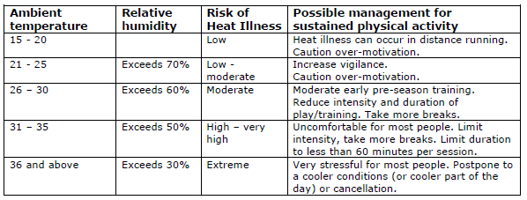
Notes

Please note that the Club will defer to the relevant Rules of Competition in relation to Extreme Weather for all affected fixtures. Specifically, in that FV, the Regional Association, and/or the Match Official may delay, postpone, or abandon any fixture due to weather and pitch conditions such as (but not limited to) excessive heat/humidity, cold temperatures, lightning, hail, rain or air quality that may endanger participants health and/or safety.
Disclaimer
DISCLAIMER: While all care has been taken in the preparation of this material and the entire FV Resource Library, no responsibility is accepted by the author(s) or Football Victoria, its staff, volunteers or partners, for any errors, omissions or inaccuracies. The material provided in this resource has been prepared to provide general information and guidance only. It is not intended to be relied upon or be a substitute for legal or other professional advice. No responsibility will be accepted by the author(s) or Football Victoria or its staff, volunteers or partners for any known or unknown consequences that may result from reliance on any information provided in this publication.

